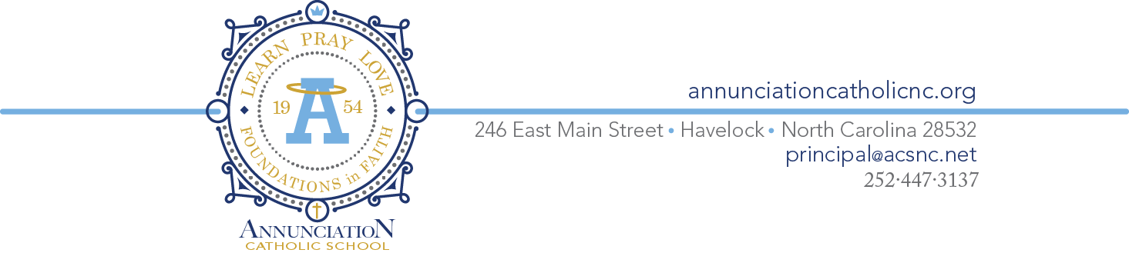
Angels and Saints
18th Annual Silent and Live Auction
March 16, 2024

Company or Individual Name: ____________________________________________________

Address: _____________________________________________________________________

Contact Person: _______________________________

Email: _______________________________________ Phone: _______________________

The Annual “Angels and Saints” Gala celebrates the mission and legacy of providing an academically excellent foundation in faith and empowering students to reach their full potential in all facets of their lives. At the heart of the mission of Catholic education is the belief that every child is blessed with God-given gifts and talents. Every day, our school seeks to nurture and draw forth these gifts and talents. Your sponsorship of the “Angels and Saints” Gala will support the continued education and empowerment of our Annunciation Catholic School students.

Please select from the following options:

Sponsorship Options:

_____ Saint Level: $500
3 Gala tickets, Full page ad in the Gala program, Logo inclusion in event signage, Logo inclusion on event website, Verbal recognition during event, Name listing on the school social media and church websites and acknowledgment in church bulletin

_____ Angel Level: $250
2 Gala tickets, Half page ad in the Gala program, Logo inclusion in event signage, Logo inclusion on event website, Verbal recognition during event, Name listing on school social media and church websites and acknowledgement in church bulletin

_____ Hero Level: $150
1 Gala ticket, Quarter page ad in the Gala program, Logo inclusion in event signage, Verbal recognition during event, Name listing on school social media and church websites and acknowledgment listing in church bulletin

Additional Sponsorship Options:

_____ Family Level: $100, business card size ad in Gala Program

_____ Friend Level: $50, special mention in the Gala Program

Please complete this form and return to Annunciation Catholic School with payment before March 8, 2024.
Please make checks payable to Annunciation Catholic School. Advertising information should be emailed to aspa@acsnc.net.

