Please consider donating an item for our Gala! All proceeds benefit our Catholic School.
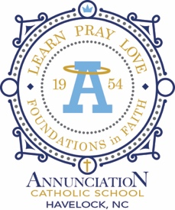
2024 ANGELS & SAINTS AUCTION INFORMATION FORM
(Please print your name and/or business name as you would like it to appear in our Auction Program)
Donor:_________________________________________
Contact Person (if different):______________________________
I am a: ____Alumni ______Business _____Friend. _____Parent _______ Alum Parent

Address: ___________________
Phone :( )____________________
Fax :( )______________________
Email:________________________ May we place your item online? Y N
Annunciation Catholic School is a 501 c (3) nonprofit organization.
Value of Donation $_______________
Date/Restrictions: __________________________________________________
Unless otherwise specified, all donations are understood to be valid for one year from the Auction Date
Donation Description
(Include quantity, size, color, number of rooms, number of persons per night, price per item, etc.)

PLEASE NOTE: Our deadline for donations is Thursday, March 7, 2024.
Donor Signature: ______________________________Date___________________________

